Use Case Description
Use Case: Approve Registered Course
ID: UC 5
Actor:
Academic Advisor
Preconditions:
- It is the end of student submit registered course
Flow of events:
- The use case starts when it is the end of student submit registered course
- Academic Advisor view the submission from the students
- Academic Advisor approve the submission
- If the student wants to adjust the submission
4.1 Academic Advisor will resend the submission
4.2 The use case terminates
- The system will display that Academic Advisor have been approve on the student email.
Postcondition:
1. The student will receive the approval from Academic Advisor

Sequence Diagram
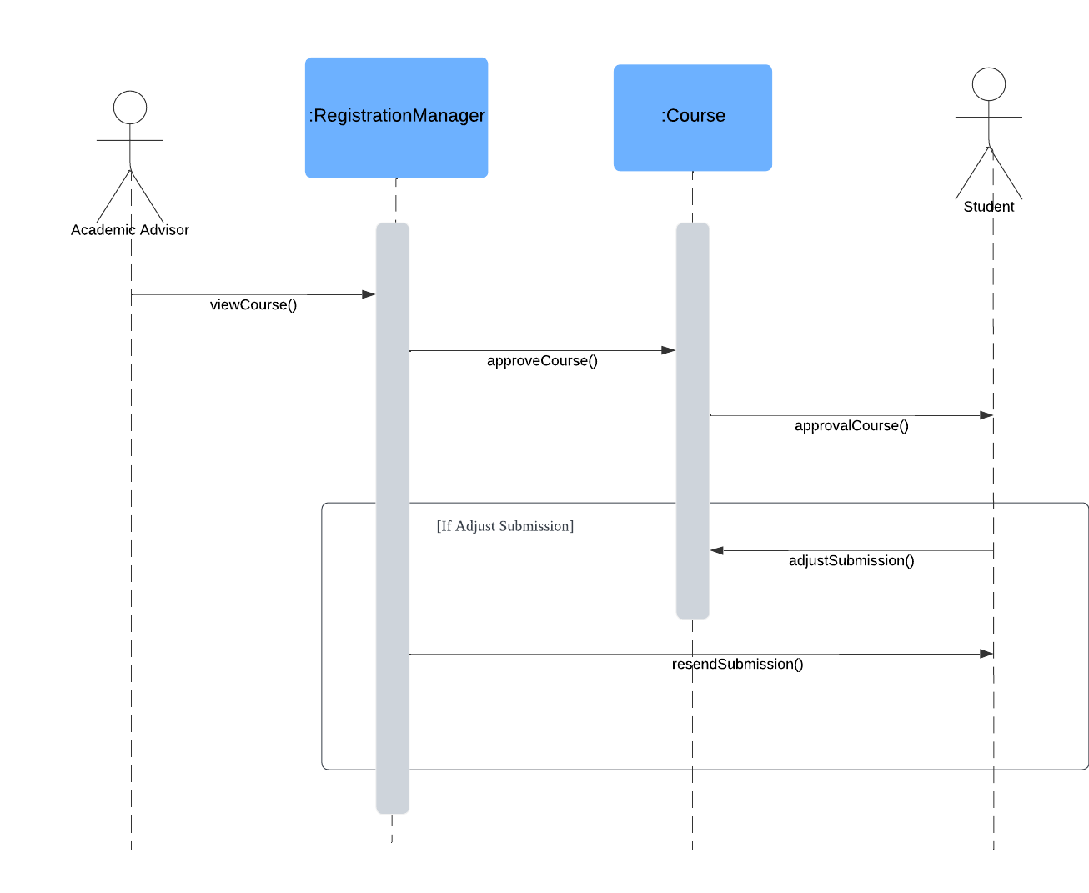
Activity Diagram
